Legal Issues Pertaining to a Kansas Teaching License
General Questions? Contact Kerry Schuckman, FHSU Licensure Officer, 785-628-4542 or kschuckm@fhsu.edu or KSDE Assistant General Counsel, Kelli Broers, 785-296-3204, kbroers@ksde.org. Note, the KSDE Office of General Counsel does not advise school districts or private individuals.
KSDE Legal Process
- If anything shows up on a background check for an application for a teaching license, it will automatically be referred to KSDE Legal Dept.
- If a conviction was expunged, you do not need to disclose it on the application. If you wait to expunge it until after you’ve submitted your application and KSDE is aware of the conviction, they will handle it as any other offense that they are aware of. (see Expungement below)
- KSDE can, and will, look at diversions unless it has been expunged.
- These offenses do not require a hearing and you do not need to mark “yes” on the application:
  - DUI (if it is the 1st or 2nd one—a misdemeanor)
  - Battery
  - Traffic offenses
  - Criminal damage to property
  - MIP
- These offenses will require a hearing:
  - Theft (misdemeanor or felony)
  - Possession of drugs/paraphernalia
  - Crimes involving children, including “hosting” minors
- KSDE’s recommendation is to submit fingerprints right away when you are nearing time to want to get your license. KSDE Legal Dept will not review your case or contact you until the license application has been received. Hearings fill up quickly and are not held every month – could be a 4-6 month process before the outcome is known.
If you receive a letter from the KSDE Office of General Counsel:
- follow all directions carefully and submit all documents they request. KSDE cannot provide you with advice or help you obtain those documents;
- you will need to contact the Clerk of the Court to obtain documents related to your case:
  - for Convictions-
    - obtain certified copies of the charging documents (complaint or citation/ticket); and
    - obtain certified copies of the journal entry of conviction.
  - for Diversions-
    - obtain certified copies of the charging documents, and
    - certified copy of the diversion agreement; and
    - certified copy of the journal entry of dismissal.

- you may be instructed to appear at a hearing before the Professional Practices Commission (a KSDE committee of working teachers, KSDE and Higher Education representatives); and
- any decision from the Professional Practices Commission will go before the State Board of Education for final action.
- just because you may have had an emergency sub license approved does not guarantee a teaching license will be!
Good Things to Know
- Example: If someone has a diversion agreement for possession of small amount of pot, should mark “no” to being convicted of a felony, “no” to being convicted of any crime involving drugs, etc. and “yes” to have you entered into a diversion agreement for drugs.
- Someone does not need to have a criminal conviction in order to have a license denied.
- Applicants don’t get the results of their fingerprint check unless KSDE Legal Dept contacts you.
- If you had an Emergency Substitute Teaching License issued and you had disclosed something at that time, you still need to disclose it again when applying for another license.
If you:
- assume or have been told your diversion took the crime off your record – IT DOES NOT.
- are “not sure” whether you had something expunged, YOU DID NOT.
- assume you don’t have to report it because you were a juvenile – YOU MUST REPORT IT.
- “forget” your past record and you don’t reveal it, this is considered dishonesty and creates another issue with KSDE who will aggressively review your case. DO NOT LIE.
Expungement
An expungement proceeding is a type of lawsuit in which a first time offender of a prior criminal conviction seeks that the records of that earlier process be sealed, making the records unavailable through the state or Federal repositories. If successful, the records are said to be "expunged".
Requirements often include one or more of the following:
- Fulfilling a waiting period between the incident and expungement;
- Having no intervening incidents;
- Having no more than a specified number of prior incidents;
- That the conviction be of a nature not considered to be too serious;
- That all terms of the sentence be completely fulfilled;
- That no proceedings be pending;
- That the incident was disposed without a conviction; and
- That the petitioner complete probation without any incidents.
- Time limits set by statute
  - 3 years or 5 years, depending on the offense
  - DUI = 10 years
  - Time starts when the sentence, probation or diversion ends
- Almost always handled by the court of origin
- If expunged, “petitioner shall be treated as not having been arrested, convicted, or diverted of the crime, expect that…”
Advice about getting a record expunged:
- it’s a fairly simple process that may not require a lawyer;
- can take 4-6 weeks to complete;
- start by contacting the court (county or municipal) where the conviction/diversion occurred OR look for the paperwork on the court website;
- check to make sure of the time required for an expungement to be completed;
- if it can be completed well before you apply for a license, DO IT NOW;
- if it cannot be completed before you apply, REPORT IT on your license application;
- an expungement can benefit you in more ways than just your license application!

KSDE REGULATION

91-22-1a. Denial, suspension, or revocation of license; public censure; grounds; report.

Any license issued by the state board may be suspended or revoked, or the license holder may be publicly censured by the state board for misconduct or other just cause, including any of the following:

(1) conviction of any crime punishable as a felony
(2) conviction of any crime involving a minor;
(3) conviction of any misdemeanor involving theft;
(4) conviction of any misdemeanor involving drug-related conduct;
(5) conviction of any act defined in any section of article 36 of chapter 21 of the Kansas statutes annotated; -- Bigomy, Incest, Abandonment, Nonsupport, Endangering a Child, Furnishing Alcohol to a Minor, Contributing to Child Misconduct
(6) conviction of an attempt under K.S.A. 21-3301, and amendments thereto, to commit any act specified in this subsection;
(7) commission or omission of any act that injures the health or welfare of a minor through physical or sexual abuse or exploitation;
(8) engaging in any sexual activity with a student;
(9) breach of an employment contract with an education agency by abandonment of the position;
Contracts bind both teachers and board of education; suspension of license;
“If upon written complaint, signed by 2/3 of the members of the board of education of the school district, any teacher who is reported to have entered into a contract with another school or board of education without having been released from such former contract, or for other reasons fails to fulfill the provisions of such contract, such teacher, upon being found guilty of such charge at a hearing held before the state board of education, shall have such teacher's license suspended for the remainder of the term for which such contract was made.”

(10) conduct resulting in a finding of contempt of court in a child support proceeding;
(11) entry into a criminal diversion agreement after being charged with any offense or act described in this subsection;
-- Diversion for ANY OFFENSE – this includes Juvenile charges
(12) obtaining, or attempting to obtain, a license by fraudulent means or through misrepresentation of material facts; or
-- Filling out the application incorrectly, failing to disclose may be perceived as a misrepresentation
(13) denial, revocation, cancellation, or suspension of a license in another state on grounds similar to any of the grounds described in this subsection.

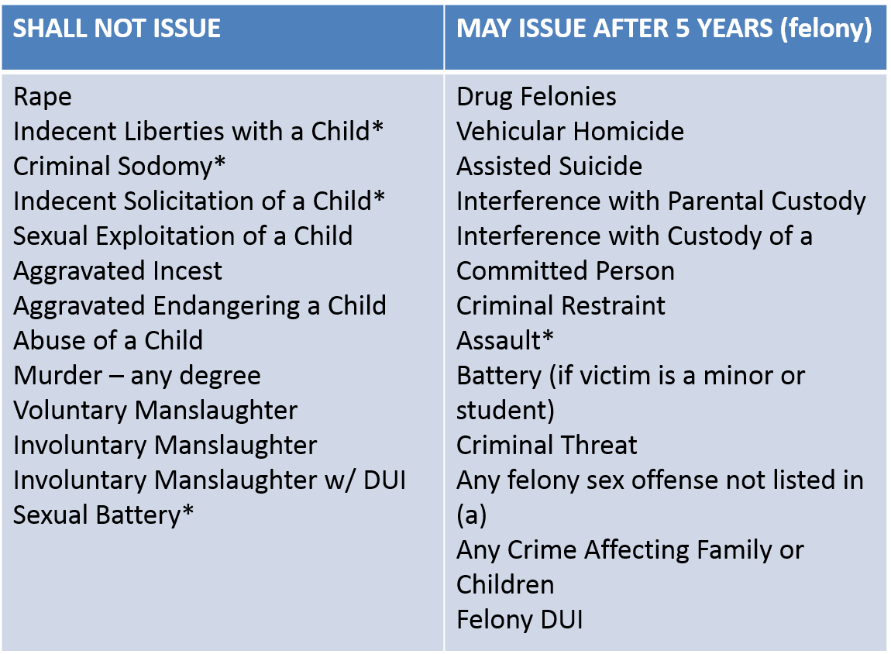

Statutory Restrictions on Issuance
and Renewal of Licenses K.S.A. 72-1397

