

Dear Tiger,

I would like to wish you and yours a wonderful holiday season. The fall semester is coming to an end. Students, faculty, and staff had a great semester, but are looking forward to time with family and of celebration.

**FHSU to Offer Entrepreneurship Camp for High School Students**

Dr. Robert Lloyd, Assistant Professor of Management at Fort Hays State University, recently received a grant from the *Fred and Mary Koch Foundation* to host a summer camp for high school students interested in learning more about entrepreneurship. The Fort Hays State University Entrepreneurship Camp will be offered for the first time on FHSU’s campus, and it will afford high school students from across the country the opportunity to work with like-minded students wishing to pursue entrepreneurial endeavors.

“We’ve got some passionate speakers coming in to engage the students and discuss concepts such as idea generation, creativity, and corporate entrepreneurship," Lloyd said.   
"The end-game of the camp is to help students find their entrepreneurial energy.”

The grant fully covers the cost of participation for 30 high school students who will be selected via a competitive process. The camp will be hosted on FHSU’s campus in the Dane G. Hansen Scholarship Hall for Entrepreneurship from June 1-4, 2018. For more information, please follow this link: <http://fhsu.edu/entrepreneurship-camp/index.html>

**Robbins Banking Institute**

The new Robbins Banking Institute continues to gain support and recognition. Director Alan Deines is building an extensive network of contacts with banks across Kansas. The response from bankers to this institute has been extremely positive. Kansas Bank Commissioner Miki Bowman has visited campus twice since the Institute’s inception and has joined bankers in speaking to classes. On the national level, Martin J. Gruenberg, Chairman, Federal Deposit Insurance Corporation of the FDIC, has learned of the FHSU effort and mentioned it in a speech delivered in Illinois on October 21, 2017.

At the Kansas Financial Services Summit on September 21, 2017, the Robbins Banking Institute was praised by multiple industry speakers as an initiative very much aligned with industry needs. The Kansas Bankers Association’s magazine and other publications have provided extremely positive coverage of the Institute.

**Kansas Insurance Certificate**

Fort Hays State University has taken a leading role in delivery of the Kansas Insurance Certificate. During the fall semester students met the criteria to earn $500 scholarships from the Kansas Insurance Foundation by passing FIN 631 Risk Management and enrolling in another course in the Kansas Insurance Certificate for the spring semester. Students completing this certificate may earn up to $2,000 in scholarship assistance as well as earning a valuable credential for use in the financial service world. More information about this certificate is available at: <http://www.fhsu.edu/efa/finance/Kansas-Insurance-Certificate/index.html>

**FHSU’s Entrepreneur Fall Direct Lecture Series Featured Couple Entrepreneurs**

Fort Hays State University’s Entrepreneur Direct Lecture Series has featured a variety of individuals who are successful entrepreneurs. It has also showcased entrepreneurs who have worked, or whom are working, as part of teams. For the Fall 2017 installment of the Entrepreneurship Direct Lecture Series held on November 7, the university showcased a special type of team. It featured two married couples who have built successful business entrepreneurial careers and personal lives. Rick and Gail Kuehl of Hays and Gail and Cindy Boller of Norton told their stories. The entrepreneurs presented in a large public session and interacted with smaller groups of students, faculty and alumni during their day on campus. If you would like to view their presentation, follow this link: <https://youtu.be/Ev8lUaKvnUM>

**Spain Study Abroad Trip May 2017**

Ten students from the Robbins College of Business and Entrepreneurship participated in a short-term study abroad course that combined a study abroad trip to Spain with a course in international business and economics. The course, International Experience in Business and Economics, emphasized topics related to international business in the context of the Euro Area and Spain. Current events from *The Economist*, the World Bank, and the Spanish local newspapers were used to complement the course topics. The capstone event for the course was a two-week trip to Spain, which included visits to Barcelona, Madrid, Segovia, Toledo, Granada, Cordoba, and Seville.  The trip provided students with a first-hand experience in Spanish business practices and culture, as well as an applied understanding of economic issues related to international business. The course and trip were led by Dr. Emily Breit and Dr. Sam Schreyer, both Associate Professors in the Robbins College of Business and Entrepreneurship. The students who participated in the short-term study abroad course are listed below by hometown, status at the time of the course, and major:

* Salina: Morgan Bryant, junior majoring in Management
* Tonganoxie: Alissa Donnelly, senior majoring in Accounting
* Claflin: Aubrey Kempke, senior majoring in Accounting
* Kansas City: Vilma Maldonado, senior majoring in Management
* Wakeeney: Jordan Olson, senior majoring in Finance
* Victoria: Cody Scheck, graduate student in the Masters of Business Administration program
* Wichita: Brianna Spexarth, junior majoring in Management
* Kansas City: Cristal Ugarte, senior majoring in International Business and Economics
* Concordia: Zoe Walsh, junior majoring in Marketing
* Hays: Chloe Zimmerman, senior with a dual major in Finance and Accounting

**Annual Winter Etiquette Dinner**

On November 28, 2017, the *FHSU Collegiate DECA* and *FHSU SHRM* *Chapter* (Society for Human Resource Management), hosted the 3rd Annual Winter Etiquette Dinner, at the Smoky Hill Country Club. In attendance were ***130*** Students, Professors, and University/Community professionals. An evening that was filled with networking and a great 4-course meal, was highlighted by Gail Kuehl, local McDonalds franchise owner, who facilitated the discussion on etiquette and professionalism. Students not only left with a newfound knowledge of professional etiquette, but also each received a pocket guide to professional etiquette from the FHSU Career Services Office.

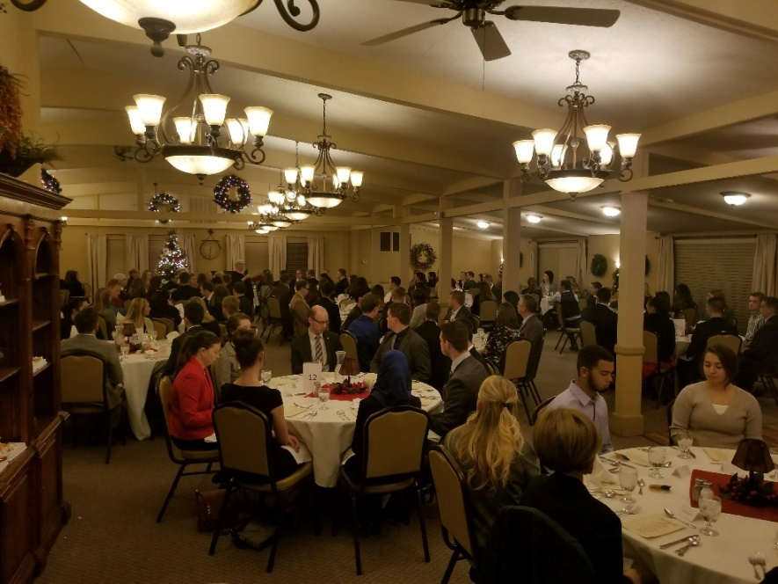

**Kansas Startup 2017**

Fort Hays State University held its sixth Kansas Startup on November 10, 11 and 12. Over 41 participants worked in 7 teams over 48 hours, once again making this the largest Entrepreneurial event in Kansas.

Before pitches on Friday evening, US Senator Jerry Moran spoke to the participants about the importance of Entrepreneurship and new ventures to the state's and nation's economy.  He praised the students for their work and encouraged them to continue their work here in Kansas.

Kansas Startup is possible because of the support of our donors and many volunteers, including our outstanding coaches: Dr. Nicholas Caporusso, Informatics; Mr. Josh Dreher, Bank of Hays;

Mr. Brad Goebel, Applied Business Studies; Mr. Scott Gross, 144 Design Co.; Ms. Mariel Huasanga Ramirez, FHSU Small Business Development Center; Dr. James Hyatt, Management;  Mr. Brandon Purdy, Simply, LLC;  Mr. Ryan Sheck, Adams, Brown, Beran & Ball;  Dr. Greg Weisenborn, Management and Mr. Charles Wolfe, Management.

Our judges this year were Dr. Michael Martin, Applied Business Studies; Dr. Candace Mehaffey-Kultgen, Management; Mr. Myrle McNeal, Sola Salon Studios and

Mr. Dennis Hodges, Creatalyst. Special thanks to co-organizers Henry Schwaller and Nicholas Caporusso, and the Department of Management, particularly LeAnn Brown. This event takes many people to put it all together.

We require every team to complete a survey at the end of Kansas Startup and have data from 2013 to the present.  The findings are excellent:

1.     Eighty percent of participants were “very likely” to recommend Kansas Startup to friends.

2.     The venue, food, coaches and facilitator rated much higher than last year.  All teams agreed that the Robbins Center is a perfect location for the event and eighty percent rated the facilitator as “excellent.”

3.     Sixty percent of participants came to Kansas Startup came to pitch an idea.  The remainder came to network (20 percent) or seek mentorship (20 percent). This demonstrates that participants are becoming more Entrepreneurial and taking the initiative to test new ideas and launch ventures. This is due, in part, to this event and our Entrepreneurship curriculum.

The top three teams were:

**First Place**

**Linking Hearts** *(a private social media app linking elderly nursing home residents, families and caregivers)*

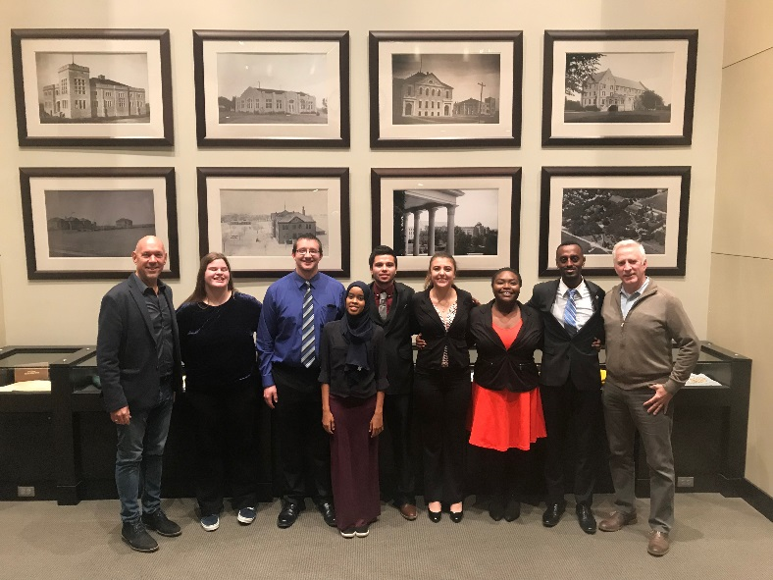

Feysel Rahmeto

Pablo Garcia

Sabaha Hassen

Tyler Grant

Kristen Bates

Katelyn Herl

Daikota Perry

**Second Place**

**Glazed** *(food truck specializing in donuts)*

Ector Diaz

Cam Charbonneau

Juan De La Cruz

Ty Yager

**Third Place**

**Ignis** *(self-contained fire starter for remote, extreme locations)*

Parker Holterman

Karoline Harrer

Kansas Startup 2018 will be held on the weekend of November 9, 10 and 11.

**FHSU/WSU Partnership Recognized**

The WSU Center for Management Development and the FHSU Management Development Center was recognized nationally as one of three finalists for “Best Partnership Program” for the joint Project Management Workshops/Program through ProEd Corporation which provides the annual Conference on Management & Executive Development (CMED).

**Management Major Kenneth Iheme Nominated for Harlon Hill Trophy**

FHSU senior management student Kenneth Iheme, was one of 34 candidates in NCAA Division II nominated for the Harlon Hill Trophy. This is an award presented to the Division II College Football Player of the Year. Iheme, a Kansan, graduated from Wichita Heights High School. He red-shirted during the 2015 season due to injury, and has played four years for the Tiger Football team. For more information on Kenneth’s football achievements visit:

<http://fhsuathletics.com/news/2017/11/21/football-iheme-nominated-as-candidate-for-harlon-hill-trophy.aspx>

**Thank you!**

I appreciate the opportunity to share updates and to connect with you. The Robbins College of Business and Entrepreneurship is successful due to the enthusiasm and hard work of students, faculty, and staff. We could not succeed without the support of family, friends, and alumni.

You make a difference. I wish you the best in 2018!

Sincerely,

cid:image009.jpg@01D34D7C.31E65B20

Mark Bannister, Dean  
Robbins College of Business and Entrepreneurship

101 McCartney Hall  
600 Park  
Fort Hays State University  
Hays, Kansas 67601-4099  
  
Phone:  785.628.5339  
Fax: 785.628.5398  
Email:  [markbannister@fhsu.edu](mailto:markbannister@fhsu.edu)  
Web:  <http://www.fhsu.edu/cob/>  
  
"If you want one year of prosperity, grow grain.  If you want ten years of prosperity, grow trees.  If you want 100 years of prosperity, grow people."  Old Chinese Proverb

