

**FORT HAYS STATE UNIVERSITY**

College of Education

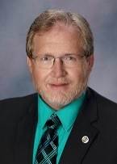

Hello to all of our members of the Tiger Teacher Nation. I am happy to share our current happenings, successes, and accomplishments from the FHSU College of Education. We continue to be critical in providing education leaders for the needs of PK-16 from our early childhood, teacher preparation, school administration programs, and higher education and student affairs. Members of the Tiger Teacher Nation are present not just in Kansas, but across the country working to make a difference in their chosen professions.

I recently attended a meeting of the *Educate Kansas Dialogue Summit: Retention*. There were many valuable ideas and insights shared at the meeting. One of the problems we have with teacher vacancy and supply in Kansas centers on recruiting the next generation of teachers. A review of the production of teachers in Kansas indicated that enrollments in teacher preparation have had modest to flat growth. Further, the addition of multiple pathways into teaching in Kansas has not bridged the gap. What have we done to show the students of today that being a teacher, an educational leader, is a profession that is valued, recognized, and rewarded? Dr. Randy Watson, Kansas Commissioner of Education, noted that that some of this is not just society at large, but resides in the profession itself based on the number of school districts that do not actively participate in nominating their best teachers for awards, such as the Kansas Teacher of the Year or Horizon Awards. We are is working to address these issues. Currently, we are reviewing how we advise students into teaching and realigning our scholarship efforts and partnerships with schools to aid recruiting the next generation of teachers. If you know of someone at any age thinking about teaching, send them our way. As a Tiger Teacher Nation member you are our best recruiter.

To aid in retention of individuals for teaching, we are developing programs to enhance ongoing professional learning. Dr. Moore, Interim Chair of the Advanced Education Program, and Dr. Haynes, Assistant Dean, have been funded to develop on-line professional learning modules. Dr. Jochum and his team are in the process of developing career-enhancing MSE options through Teacher Education. Dr. Andersen is working with the secondary discipline faculty to enhance the Transition-to-Teaching program. Dr. Chappell is working with Dr. Becking and Dr. Jones, to develop a new EdS pathway in digital leadership. Dr. Haynes has been working with Dodge City Schools to provide coursework leading to ESOL certification. We have also worked with the Chemistry and Mathematics Departments to develop an MSE concentration to prepare teachers to provide concurrent credit within schools. If you are aware of opportunities or needs that we should address contact me. I always welcome the input from members of the Nation.

Enjoy reading about your college. If you have items to share about yourself or other Tigers, please let us know as we want to celebrate your successes.

Be safe, be well!

FROM THE DEAN

**Dr. Paul Adams**Dean, College of Education, Anschutz Professor of Education, Professor of Physics  
785-628-5344  
padams@fhsu.edu

The mission of the College of Education is "Education professionals prepared at Fort Hays State University will have the technological, pedagogical and content knowledge, skills and dispositions to lead, model, teach and collaborate in diverse settings."



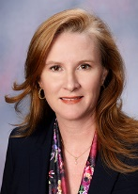

TEACHER EDUCATION DEPARTMENT

**Dr. Brooke Moore**Interim Chair, Advanced Education Programs, Assistant Professor  
785-628-5568  
bamoore4@fhsu.edu

The mission of the [Advanced Education Programs (AEP) Department](https://www.fhsu.edu/aep) is to prepare 21st century global leaders who serve in educational and community settings. The foundational link connecting all of our graduate programs is leadership. Our graduates have the capacity, drive, and ability to serve as leaders wherever they may be.

Leadership in pre-kindergarten through higher education settings is broad. Not all candidates become principals or superintendents. In fact, not all candidates view themselves as leaders. Instead, they are [Reluctant Leaders](https://www.forbes.com/sites/forbescoachescouncil/2017/06/22/how-to-identify-and-prepare-leaders-who-are-reluctant/#6a8e5a784864) – they may define leadership as a role or position (e.g., principal, vice-principal), not as characteristic traits. Consequently, they do not see themselves as leading, when in reality, that is what they do.

In a recent College of Education Data Retreat, we met with district leaders around the state who consistently noted that they expect their faculty with graduate degrees to step up as leaders in schools. To them, *stepping up* means advocating for students and parents, organizing and leading professional learning among colleagues, or even to serve as a mentor to new teachers. As Shanna Dinkel, Assistant Superintendent of Hays USD 489 states, “Teacher-leadership is encouraged and supported in Hays-USD 489. I am continually amazed with staff who willingly take on leadership roles and commit to their own personal, professional growth for the improvement of our system and, more importantly, the success of our students.”

While we continue to develop highly qualified building and district leaders, faculty and staff in the AEP Department are purposefully exploring ways we can better support candidates across programs to transition from begin *reluctant leaders* to becoming strong *teacher-leaders*. Drawing from the Professional Standards for Educational Leaders (PSEL), we have identified three key cross-cutting leadership themes for developing reluctant leaders. We envision our graduates as having the capacity to:

1. Understand, Build and Lead a Shared Vision
2. Foster an Ethical, Productive and Responsive Organizational Culture
3. Enact Continuous Improvement Processes

As the Interim Chair of the AEP Department, I invite you – our alumni and friends – to support our work. Connect with us to share your stories of reluctant leaders awakening to their inner leadership. Help us develop the next generation of global leaders serving in educational and community settings.

ADVANCED EDUCATION PROGRAMS

[The Teacher Education (TE) Department](http://www.fhsu.edu/te/) at FHSU continues to prepare quality teachers through on-campus and virtual programs, which has enabled our department to reach students within the state of Kansas and throughout the country. As we start the 2018-2019 academic year, we are pleased to serve close to 1300 education majors. We have seen a 16% increase in our on campus enrollment over the past year.

Our success is directly related to the hard work and dedication of the excellent faculty and staff who are committed to student success and retention. We look forward to working with first-time and transfer students through events such as Tiger Day, Tiger Mania, Tiger Stripes, Majors and Graduate Programs Fair, Hispanic College Institute and Student Recognition and Programs.

The mission of the [Advanced Education Programs (AEP) Department](https://www.fhsu.edu/aep) is to prepare 21st century global leaders who serve in educational and community settings. The foundational link connecting all of our graduate programs is leadership. We produce graduates with advanced educational degrees (Master’s or Education Specialist) who have the capacity, drive, and ability to serve as leaders wherever they may be.

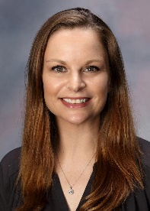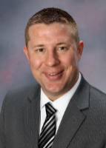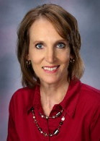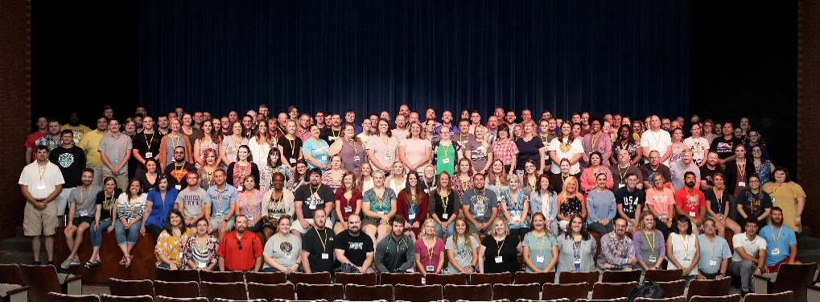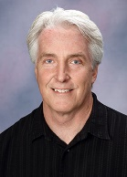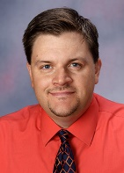

**Kerri Snow**, Instructor of Teacher Education, was born and raised in a small town in Southern, IN just 10 miles north of Louisville, KY. She received both her Bachelor (2003) and Master (2007) degrees from Indiana University. For the last 14 years she has been teaching in public schools within Indiana and Kentucky. Her experience includes teaching Kindergarten for six years and Technology (grades K-6) for eight years. She recently moved to Hays to become a full-time Instructor for the Department of Teacher Education. She is married to Dr. David Snow, Director of Entrepreneurship at FHSU. In her spare time, she likes to go camping, enjoys crafting, and spending time with her family and three pugs; Bubba, Bailee, and Brindlee.

WELCOME THE NEW STAFF

**Dr. Chris Jochum**Chair, Teacher Education  
785-628-4213  
cjjochum@fhsu.edu

The Advanced Education Programs’ Transition to Teaching program is breaking enrollment records year after year. Currently there are 180+ new teachers hired by Kansas schools representing 90 school districts that are beginning FHSU’s alternative licensure program for the 2018-2019 school year. This puts our numbers at over 300 between those that started last year and the newcomers.  
  
These teachers have bachelor’s degrees or higher, a major in a content area or the equivalent, and have passed a content exam. They work under a restricted teaching license while taking the education courses over a two year period to qualify for their full license. Each summer, the program hosts a four day Induction class on campus which serves as a “boot camp” to prepare the teachers to step foot into the classroom. It also provides a great opportunity for attendees to make connections with other teachers that will be teaching their subject area and other teachers hired for this program in their school district.

**Ms. Kerry Shuckman**T2T Asst. Coordinator  
785-628-4542  
kshuckm@fhsu.edu

**Dr. Gary Andersen**T2T Coordinator  
785-628-4622  
ggandersen@fhsu.edu

TRANSITION TO TEACHING

[The Teacher Education Department](https://www.fhsu.edu/te/) is housed in the College of Education and provides undergraduate programs for students preparing to be educators in Kansas and across the nation in the following areas:

* Elementary Education (K-6)
* Secondary Education (7-12)
* Early Childhood Unified (Birth to Grade 3)
* Special Education (K-12)

ADVANCED EDUCATION PROGRAMS



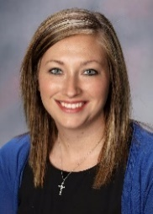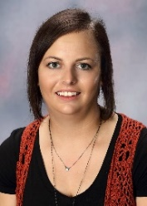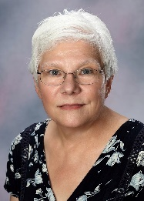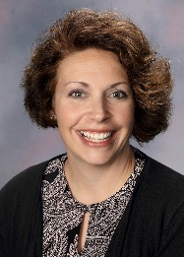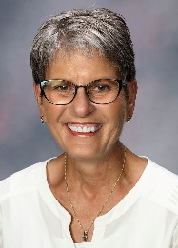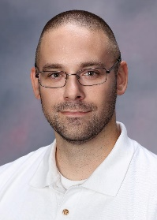

**Phillip A. Olt** is an Assistant Professor of Higher Education Student Affairs in the Advanced Education Programs Department at Fort Hays State University. He earned his Ed.D. in Educational Administration from the University of Wyoming, M.Ed. in Educational Leadership and B.A. in History from the University of West Florida, and A.A. in General Studies from the University of Alaska Anchorage. His research interests include the (1) impacts of regulatory compliance on higher education, (2) interactions of distance students with faculty and staff, and (3) emergent and hybrid qualitative research methodologies. During the summer of 2018, he moved from Wisconsin to Hays, America, with his wife Jennifer and daughter Sophia. Jennifer teaches middle school science in Russell, Kansas, while Sophia attends kindergarten. In his spare time, Phillip enjoys outdoor activities, such as fishing, hunting, hiking, and camping.

**Jerri Brooks** is a Virtual Instructor for our Advanced Education Programs. She comes to the College of Education with over 40 years as an educator. Before politically correct terms were used, she taught at the State Home for the Severely and Profoundly Retarded in Nebraska and the State Hospital for the Criminally Insane in Topeka. Then, she taught third grade before a 40-year stint, teaching students with special needs for High Plains Education Cooperative in Southwest Kansas where she still serves as mentor to new special education teachers. She has been an adjunct faculty member in the doctoral program at Southwestern College, and more than 30 years ago, she was an adjunct in the special education program at FHSU. While she is not working in academics, she enjoys spending time with her family, reading, working in her flower garden, quilting and woodworking.

**Heather Musil** is an instructor in our Teacher Education Program in Special Education. She has been a Tiger for over 20 years! She graduated from FHSU with her degree in elementary education and a master’s degree in special education. For the past 18 years, she taught as a special education teacher at the middle school level working with student who have mild to moderate disabilities. Over the years, she has had many student teachers and interns in her classroom from FHSU, and she looks forward to getting to know each one of them. She has three children who keep her very busy, and she and her husband also own a local business they enjoy. Her favorite past time is traveling to experience new and exciting places.

**Dottie Staab** has worked for the past 24 years in the University Bookstore. Dottie came to Advanced Education Programs as an Academic Program Specialist in July following the closing of the University Bookstore. She earned her Bachelors in 2003 and her MS of Science in Education in 2011 from FHSU. Dottie and her husband just celebrated their 43rd wedding anniversary and have four children. She enjoys spending time with her grandchildren, cooking, DIY projects and various crafts including building fairy gardens with her grandchildren. She and her husband also enjoy taking mini road trips to visit museums and historical sites around Kansas.

**Ashley Neuburger** is the Senior Administrative Assistant in the Department of Field Experiences and Licensure. She graduated from Fort Hays State University in 2011 with her degree in Marketing. She is excited for her journey working with students and helping to further their career in teaching. She is currently engaged and planning a May 2019 wedding here on the FHSU campus. Her favorite past time is spending time with her fiancé and two dogs and playing softball.

**Laney Roths** grew up in Salina, Kansas and completed her Bachelor’s degree in Early Childhood Education-Special Education at Kansas State University. She later returned to Kansas State to complete her Master’s in Early Childhood Education-Special Education through their online program.  Before coming to FHSU, Laney worked as an Early Childhood Wellness Specialist for Child Care Aware of Kansas, a preschool teacher, and a special education preschool teacher. Although originally from Salina, Laney and her husband along with their son are proud to call Hays home. In her free time Laney enjoys spending time with her family outdoors, at sporting events or at their downtown family business.



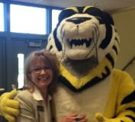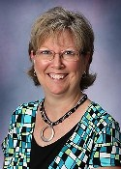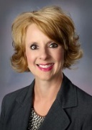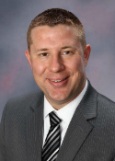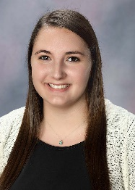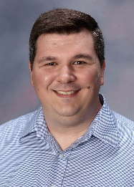

* Dr. Broman completed her Ph.D. in Curriculum and Instruction (emphasis in Literacy) from Kansas State University in the spring of 2018.
* Dr. Broman attended the World Project Based Learning (PBL) Workshop in Napa Valley, California.
* Dr. Broman developed the first Teacher Education Honor’s Program course “*Concepts of Educational Practice and Theory”* which will be offered in the spring of 2019 semester.

**Dr. Chris Jochum, Chair and Professor of Teacher Education**

* Dr. Jochum was granted tenure and promoted to the rank of Professor of Teacher Education.

**Dr. Janet Stramel, Associate Professor of Teacher Education**

* Dr. Stramel currently serves as the President of the Kansas Association of Colleges for Teacher Education and the Kansas Association of Teachers of Mathematics.
* Dr. Stramel serves on the Accreditation Council for the Council for the Accreditation of Educator Preparation (CAEP) and worked as a national site visitor trainer in the summer of 2018. Dr. Stramel recently provided eight sessions as the fall CAEP Conference in Washington, D.C.

**Dr. Valerie Zelenka, Associate Professor of Teacher Education**

* Dr. Zelenka was granted tenure and promoted to the rank of Associate Professor of Teacher Education.
* Dr. Zelenka had two sessions competitively selected for presentation at the Kappa Delta Pi Conference in Indianapolis, IN (November, 2018) and for the International Conference on Education in Honolulu, HI (January, 2019).

**Faculty Accomplishments in Teacher Education**

**Dr. Sarah Broman, Assistant Professor of Teacher Education**

FACULTY & STAFF ACCOMPLISHMENTS/HAPPENINGS

**Britny Cox** is the Internship Coordinator in the Department of Field Experiences and Licensure. She graduated in May of 2015 from FHSU with a Bachelor of Business Administration in Business Management. For the past three years, she has been in the banking industry as a consumer/small business lender and the assistant score keeper for the FHSU volleyball team since the 2014 season. Britny’s husband is a welder at Leon’s Welding & Fabrication and they just purchased a home a little over a year ago in Ellis. She enjoys watching KC Chiefs Football and spending time with friends and family.

**Brian Weber** originates from a suburb in St. Louis. He has a Bachelor’s degree in Psychology from Xavier University with Minors in Biology and Theology. While at Xavier, he was a member of the pep band and traveled the country with the XU basketball team. He then went on to get his MS in Mental Health Counseling from Indiana State University. Following this, he worked for a few years as a college counselor, academic advisor and TRIO Student Support Services advisor. He then continued his education to begin working on his Doctorate in Counselor Education at K-State. Here at FHSU, he is an instructor in the School Counseling and Clinical Mental Health Counseling programs. He is happy to be in Hays as his father grew up on a farm near Oakley, and he has several of his immediate family in the area. He is happy to be closer and be able to visit them.



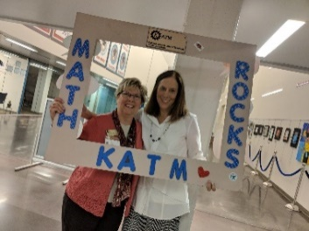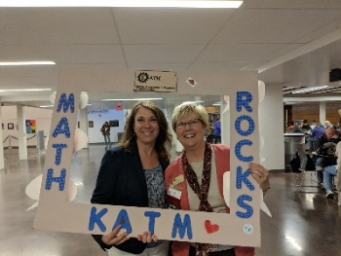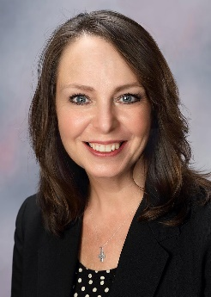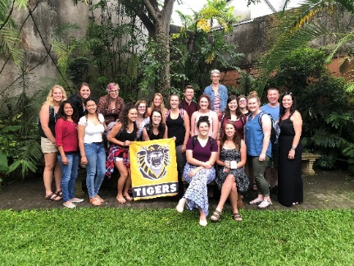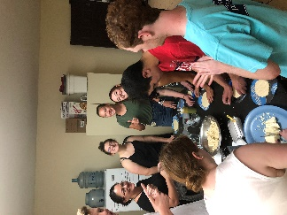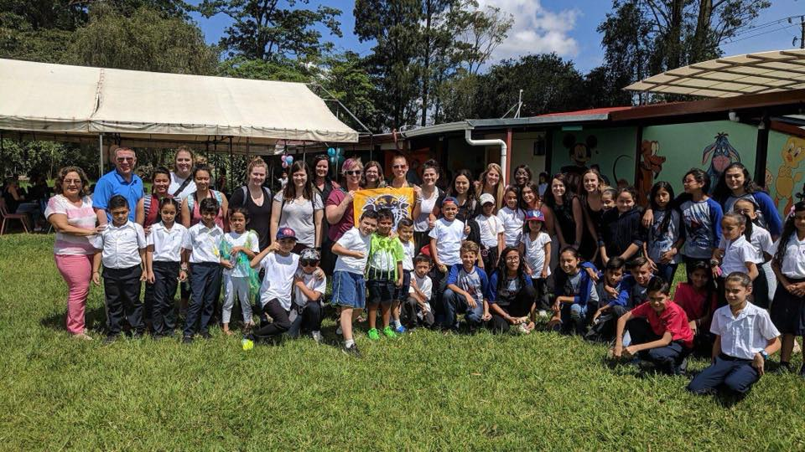

**KATM Conference**

Dr. Janet Stramel, Associate Professor in the Department of Teacher Education, recently attended the Kansas Association of Teachers of Mathematics (KATM) Annual Conference in Manhattan, Kansas. Keynote speaker for the conference was Dr. Karen Karp, John Hopkins School of Education. Dr. Karp is also a co-author of the textbook, “Elementary and Middle School Mathematics: Teaching Developmentally” that is used in Dr. Stramel’s Mathematics Methods courses at FHSU.

In addition, Dr. Stramel was able to meet one of her virtual students at the conference, Kania Shain. Kania is an Elementary Education major.

**Kansas Team Up for CACFP Nominee**

Sara Stroup, Instructor in Teacher Education and Tiger Tots, was nominated to be a part of the Best Practices presentation during the Kansas Team Up for CACFP (Child and Adult Care Food Program). She presented during the Success Workshop on November 8th in Salina, KS.  During the workshop, participants use the Institute of Child Nutrition Team Up approach to problem-solving and networking in Kansas.

The workshop provided customized technical assistance and sessions highlighting best practices in the areas of Planning and Administration of the CACFP. Sara was asked to present, focusing on highlights of what she does in this area.

**Costa Rica Trip**The Department of Teacher Education is providing current students with engaging opportunities outside of the classroom. In June, the department sponsored a ten-day study abroad trip to Costa Rica. This provided 18 future educators the opportunity to live with local host families, attend a Spanish language institute and observe an elementary school. The trip was sponsored by Dr. Chris Jochum (Chair, Department of Teacher Education) along with Dr. Elodie Jones and Dr. Betsy Crawford (Assistant Professors, Department of Advanced Education Programs). Plans are currently underway to offer the trip in June of 2019, which is open to all FHSU students. Please contact Dr. Jochum ([cjjochum@fhsu.edu](mailto:cjjochum@fhsu.edu)) for details.

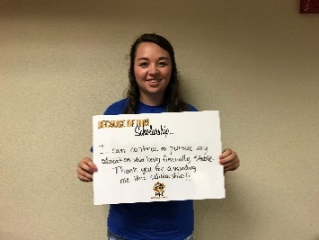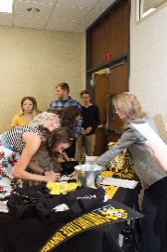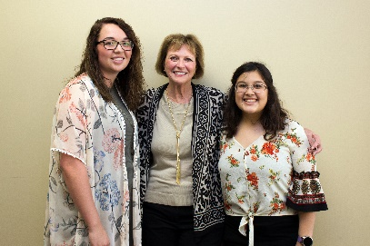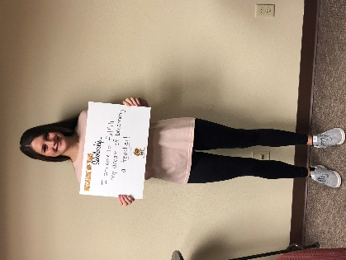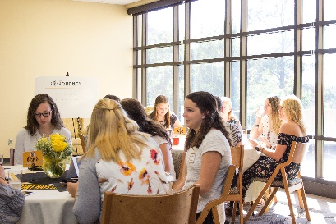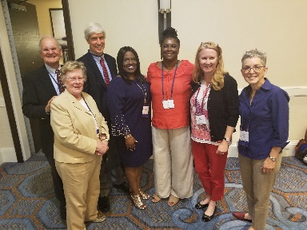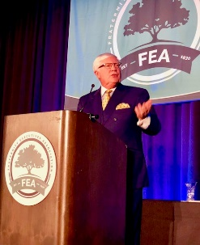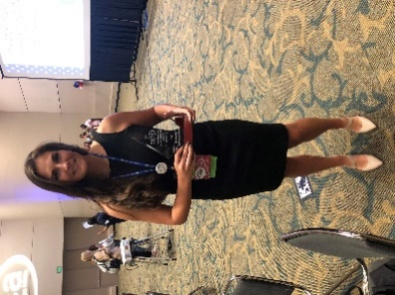

* Maggie Chitty—Gypsum, KS $300
* Holly Dethlefs—Ravenna, NE $300
* Megan Isaac—Sublette, KS $300
* Emalee Taylor—Hays, KS $300
* Rebecca Windholz—Wakeeney, KS $300
* Miranda Atchison—Kirwin, KS $600
* Danielle Riley—Cedar, KS $600
* Sydney Simmons—Grand Island, NE $600

**College of Education Scholarship Reception**

Through the work of the FHSU Foundation, students within the Teacher Education Department continue to receive support. On September 13, 2018, the Foundation hosted the College of Education Scholarship Reception, honoring donors and student recipients. In addition, due to the generosity of FHSU faculty, staff and alumni, the Teacher Education Department was able to award general scholarships to the following education majors:

The Teacher Education Department continues to benefit from the generous support provided through the kind support of our alumni.

**Faculty Accomplishments in Advanced Education Programs**

The faculty and staff of the AEP Department are dedicated professionals who demonstrate leadership qualities and consistently engage in serving as leaders in educational and community settings. Over the summer, several faculty presented at conferences.

* Dr. Kathleen Sanders and Carrie Tholstrup presented at an international reading conference in Austin, Texas, on providing support to teachers in utilizing workshop reading models.
* Dr. Elodie Jones presented at a state educational improvement conference in Lawrence, Kansas, on integrating flip grid technology into instructional practices.
* Dr. Ed Hammond presented at a national fraternity association in San Diego, California, on the benefits of participating in fraternities and sororities.

Several faculty engaged in research and/or policy-related activities:

* Dr. Brooke Moore and Dr. Jerri Haynes submitted a research grant to develop online professional development modules for teachers across the state of Kansas.
* Dr. Ed Hammond chaired the North-America Interfraternity Conference Commission on Alcohol which developed a new policy on alcohol currently featured in a [Chronicle of Higher Education article](https://www.chronicle.com/article/No-More-Hard-Liquor-at/244436).

And, several faculty attended professional trainings:

* Dr. Brooke Moore and Dr. Jerri Haynes attended the American Association of Colleges for Teacher Education Leadership Academy in Milwaukee, Wisconsin.
* Dr. Elodie Jones and Dr. Brooke Moore attended the Council for the Accreditation of Educator Preparation national site visitor training.

**NACA Awarded to FHSU Graduate Assistant**

On October 6th in Arlington, Texas, the National Association for Campus Activities (NACA) presented Bailey Talkington with the Outstanding Graduate Assistant Award. This award was presented to the graduate assistant in campus activities who demonstrates commitment to both his/her current position and graduate education. Bailey was recognized for providing outstanding service to FHSU, showing promise as a future contributor to the campus activities profession, and being creative and innovative in campus activities work at FHSU.

Bailey is a current student in the MS in Education (Higher Education Student Affairs) and graduate assistant in the Center for Student Involvement.

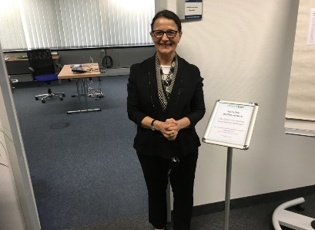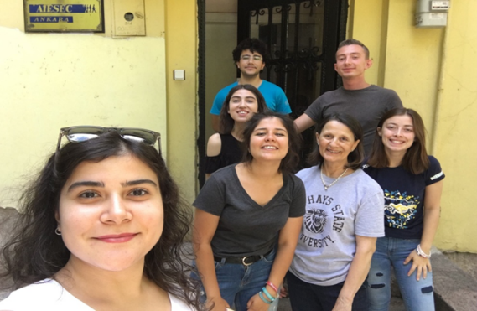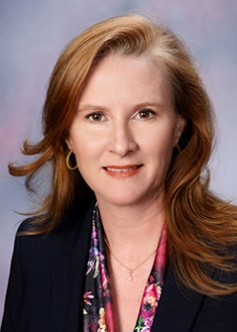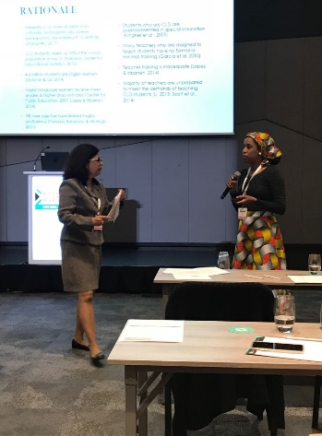

**Ward Presenting in Munich, Germany**

In July 2018, Yaprak Dalat Ward presented her paper at a conference in Munich, Germany.Yaprak attended an international multi-disciplinary conference, the International Journal of Arts and Sciences Academic Conference in Munich, Germany in July 2018, and presented a paper entitled *Teaching and Learning Cultural Diversity for Changing Times.*

**AIESEC in Ankara, Turkey**

In August 2018, Yaprak Dalat Ward trained student leaders of AIESEC in Ankara, Turkey.AIESEC is a student organization which allows young people to develop their potential in an international environment, through volunteering and internship opportunities. Founded in 1948 in 7 countries in Europe to prevent similar conflicts as WWII, AIESEC has over one million global users, represented by 2,400 universities, and is present in over 126 countries and territories.

AIESEC member students are committed to developing projects with 17 Sustainable Development Goals by the year 2030. The projects range from quality education to zero hunger.

**ATE Distinguished Research in Teacher Education Award**A big congratulations to Dr. Brooke Moore on her winning article, *Developing Special Educator Cultural Awareness Through Critically Reflective Professional Learning Community Collaboration,* that has been selected as the recipient of the 2019 Association of Teacher Educators Distinguished Research in Teacher Education Award.

As the recipient of the Distinguished Research in Teacher Education Award, Dr. Moore is expected to attend and present her work at the 2019 ATE Annual Meeting. This year’s meeting takes place on February 16-20, 2019, in Atlanta, Georgia. One of the highlights of the annual meeting is the Awards Banquet, at which time she will be recognized. You can learn more about the annual meeting at [www.ate1.org](http://www.ate1.org).

**FHSU Faculty Presenting in Africa**

In July 2018, Dr. Jacqueline Lubin, from Advanced Education Programs-Special Education, and Dr. Pelgy Vaz, from Sociology, presented on “Enhancing the Academic Performance of Students who are Culturally & Linguistically Diverse in Inclusive Settings” at the Council of Exceptional Children (CEC): Division of International Special Education and Services (DISES), conference in Cape Town, South Africa. The theme of the conference was *Embracing Inclusive Approaches*.

At the conference, Dr. Lubin and Dr. Vaz presented data from their research study that examined the culturally and linguistically responsive practices used in K-12 inclusive classrooms to assist diverse learners attain greater academic success. The presentation expounded on a culturally and linguistically responsive pedagogical framework (Richards, Brown, & Ford, 2007) that the impact educators’ practice in the classroom. The feedback from participants included “one of the best sessions” attended.



**Outstanding Advising Award Winner**

Dr. Brooke Moore, interim chair of Fort Hays State University’s Department of Advanced Education Programs, was selected as an Outstanding Advising Award Winner in the Faculty Advising category as part of the 2018 NACADA Global Awards Program for Academic Advising.

This award is presented to individuals who have demonstrated qualities associated with outstanding academic advising of students. The Faculty Academic Advising category includes those individuals whose primary responsibility is teaching and who spend a portion of their time providing academic advising services to students. The award was presented at the recent NACADA Annual Conference in Phoenix, Ariz. Her advisees supported her nomination for the award, which honors Moore’s dedication to student success.

One student said, “She understands what each student is going through, makes time to speak and communicate with you, and will always help you find a solution to a dilemma. Many of us in graduate school are working full time, with many other obligations; Dr. Moore assisted in keeping us focused and grounded. Even at the most stressful times, I never felt like I was in dire straits.”

“This award recognizes that Fort Hays State University’s largest graduate department, Advanced Education Programs, has dedicated and determined academic advisors who are supportive of their students,” said Dr. Patti Griffin, director of the Academic Advising and Career Exploration Center.

“Dr. Moore is a true testament to the hard work and support provided to the students in the department. Their advisors have a mind and willingness to invest deeply and personally in their students and their programs,” said Griffin.

Retrieved from https://www.hayspost.com/2018/10/23/fhsus-moore-recognized-for-outstanding-service-as-faculty-advisor/

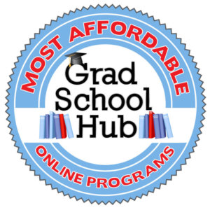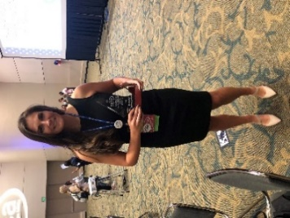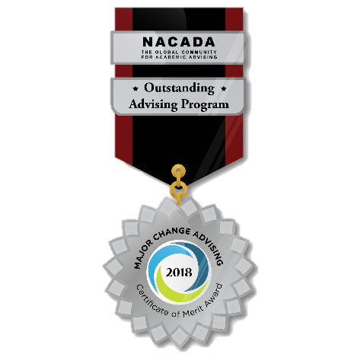

**Fort Hays State University Ranked**Fort Hays State University has been identified as having one of the most affordable online master’s in special education degree programs in a recent ranking. The ranking is based on affordability, accreditation, and other recognition.  
 **FHSU’s Graduate Tuition/Fees: $4,162**  
Fort Hays State University offers one of the most affordable special education online degrees. The online master’s in high-incidence special education program is designed for students wanting to pursue a career in special education. This fully online degree takes 18-24 months to complete, and classes are taught by Fort Hays State’s experienced professors. The degree is accredited by both the KSDE and CAEP and is aligned with the state standards. Admission requirements include a personal statement, two outside personal recommendations, official transcripts and the completion of an accredited baccalaureate degree, and a copy of your current teaching license if you are a licensed teacher. U.S. News and World Report ranks Fort Hays State as a top regional university in the Midwest. Also, the online graduate education programs rank #62 out of more than 1,200 surveyed programs.   
  
Retrieved from https://www.gradschoolhub.com/affordable/online/masters/special-education/

**NACA Awarded to FHSU Graduate Assistant**

On October 6th in Arlington, Texas, the National Association for Campus Activities (NACA) presented Bailey Talkington with the Outstanding Graduate Assistant Award. This award was presented to the graduate assistant in campus activities who demonstrates commitment to both his/her current position and graduate education. Bailey was recognized for providing outstanding service to FHSU, showing promise as a future contributor to the campus activities profession, and being creative and innovative in campus activities work at FHSU.

Bailey is a current student in the MS in Education (Higher Education Student Affairs) and graduate assistant in the Center for Student Involvement.



**FHSU Faculty Presenting in Africa**

In July 2018, Dr. Jacqueline Lubin, from Advanced Education Programs-Special Education, and Dr. Pelgy Vaz, from Sociology, presented on “Enhancing the Academic Performance of Students who are Culturally & Linguistically Diverse in Inclusive Settings” at the Council of Exceptional Children (CEC): Division of International Special Education and Services (DISES), conference in Cape Town, South Africa. The theme of the conference was *Embracing Inclusive Approaches*.

At the conference, Dr. Lubin and Dr. Vaz presented data from their research study that examined the culturally and linguistically responsive practices used in K-12 inclusive classrooms to assist diverse learners attain greater academic success. The presentation expounded on a culturally and linguistically responsive pedagogical framework (Richards, Brown, & Ford, 2007) that that impact educators’ practice in the classroom. The feedback from participants included “one of the best sessions” attended.

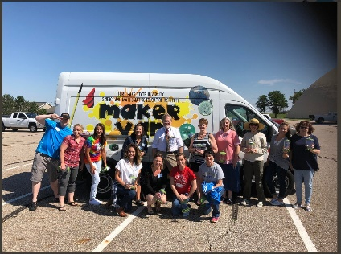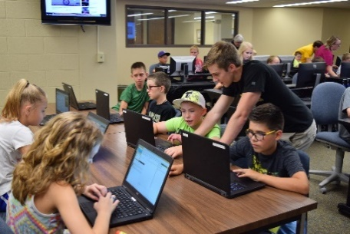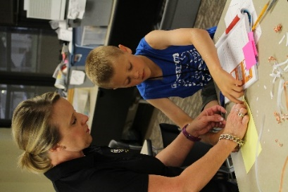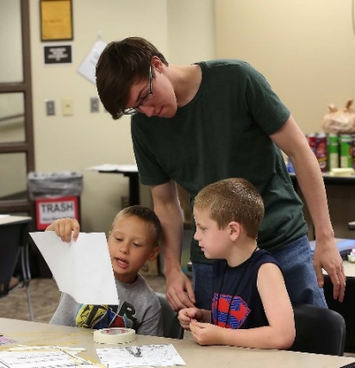

**STEM Maker Van**

Our STEM MakerVan is proving to be an exciting addition to FHSU. It has been used to move specialized programs out to schools allowing western Kansas students to experience summer camps, high altitude balloon launches, math and science workshops, robotics competition, mobile planetarium and public outreach at county fairs.

The MakerVan has been outfitted with custom STEM teaching equipment to be used by schools, youth, and community programs. If you have a need for this type of service, feel free to contact us.

We would like to take a moment to thank our very special donors who have made this project possible. Without their multiple gifts and grants, we could not provide these services for the youth of Kansas.

**Noyce Summer Scholars Help With FHSU’s Science and Mathematics Education Institute (SMEI) Youth Camps**

Josh Stark was learning about science on a day-to-day basis before he even started kindergarten. Now a junior in college, Stark is passing on to other youngsters his passion for learning all he can about science while working toward a bachelor's degree in chemistry education. Stark is one of five Fort Hays State University students who were named Noyce Summer Scholars to help with FHSU’s Science and Mathematics Education Institute (SMEI) youth camps this summer.

The Noyce Summer Scholars program or initiative and the Noyce Teacher Leader program are made possible because of a $1.1 million grant from the National Science Foundation. In addition to being chosen for the summer scholars program, Stark also was one of eight Fort Hays State students awarded a $13,000 Noyce Teacher Leader scholarship, given to junior or senior students majoring in a science or mathematics field of study to prepare for secondary teaching

Fort Hays State has been offering these camps for youngsters entering second through eighth grade for more than a decade with the goal of sparking an interest in the fields of science and mathematics.

Several of the camps include sets of siblings, including the “Building with Math” camp where students learned about George Washington Ferris Jr. Ferris created the original Ferris Wheel for the 1893 Chicago World’s Columbian Exposition.

Hays residents Agoni Smolarkiewicz, 10, and his younger brother, 7-year-old Kiros, tried an SMEI camp for the first time this summer, attending the “Building with Math” section.

“They weren’t sure what to think the first day, being their first time,” said the boys’ father, Jared. “But by the time they got to the constellation day, they were all into it. This is a great opportunity for kids. The more hands-on you make math and science, the better they will learn.”

Ann Noble, financial administrator for SMEI, said her granddaughter looks forward to coming to the camp from Olathe each summer. This year, 8-year-old Laney Velleca brought along her younger brother, 7-year-old Cooper, to the "Building with Math" camp.  
  
Retrieved from <https://www.fhsu.edu/news/2018/07/summer-experience-a-boon-for-fhsu-teaching-hopefuls>



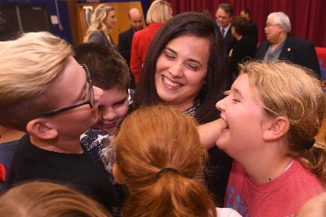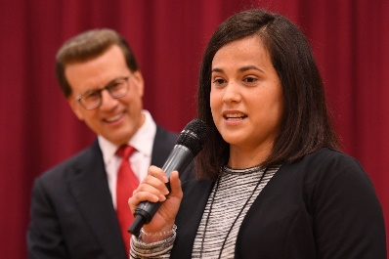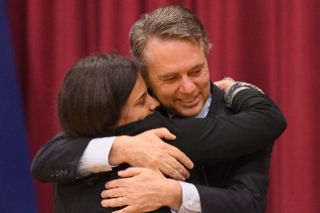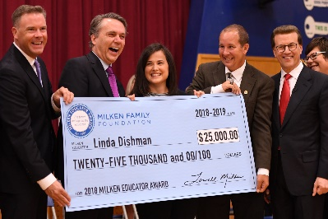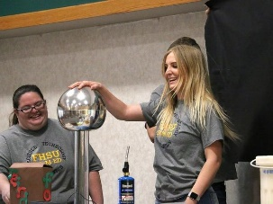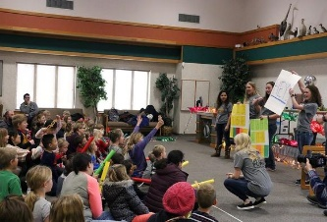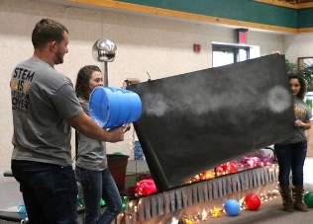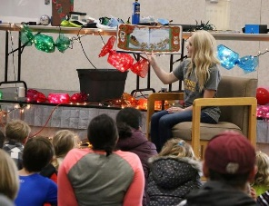

**FHSU Alumni Wins Milken Educator Award**Fifth-grade teacher from Berryton Elementary School, Linda Dishman was surprised with a 2018 Milken Educator Award. Dishman was named the nation’s first 2018-19 recipient of the national recognition, known as the “Oscars of teaching,” which comes with an unrestricted $25,000 cash prize. She is the only Milken Educator Award winner from Kansas this year, and is among up to 40 honorees for 2018-19.

Eric Deitcher, president of the Shawnee Heights Unified School District 450 Board of Education, said Dishman was “stellar.”

**“Twas the Night Before Christmas” STEM-Ed Christmas Presentation**

FHSU’s STEM-Ed students held a scientific presentation for kids called “Twas the Night Before Christmas” where they explained how Santa’s reindeer can fly, how Santa can fit down the chimney, how to play Jingle Bells out of Bangwhackers, how Santa can tell who is naughty or nice, and many other magical Christmas wonders. The STEM-Ed students who put this Christmas show on were Raquel Tomsic, Breanna Meier, Emalee Taylor, Lane Bigge, Trisha Kiser, Chantal Solorzano, Perla Camacho-Rosales, Alexis Meinert, Diana Sabados, Josh Stark, Kate Westerhaus, and Shawna Serpan.

While FHSU junior Kate Westerhaus read a storybook of a classic poem, her fellow students interrupted with the important questions about the story and demonstrated possible answers with STEM — science, technology, engineering and math. The show takes a couple of months of planning, including which story to read and what demonstrations to perform, said Emalee Taylor, president of the FHSU STEM-ED Student Chapter. Then there’s about four weeks of gathering the materials and practicing.

Diana Sabados and Alexis Meinert demonstrated how Santa infuses his reindeer feed by using the electrostatic generator by placing a box of Santa’s reindeer feed — actually puffed rice cereal — that they placed in a cup on top of the generator. As the electricity built up, the cereal pieces began flying out of the cup.

As for how a large person like Santa can fit down a narrow chimney, the STEM students hypothesized Santa brings a container of cold North Pole air with him in the sleigh that helps him shrink, but once down the chimney, he returns to normal size. They demonstrated how that would possible by placing an inflated balloon on top of a container of liquid nitrogen, whose temperature is about minus 320 degrees and the balloon deflated as the air inside condensed, then crinkled and crackled when brought out into room temperature and re-inflated.

They reached their hands in the air to try to put their hands through the smoke rings blown by a vortex cannon, and waved at the small drones the FHSU students flew overhead to show how Santa keeps tracks of who is naughty and nice.  
  
Retrieved from http://www.hdnews.net/news/20181201/fhsu-students-show-science-behind-santas-magic



“She was the perfect selection,” he said. “She’s a shining star in both Shawnee Heights and Kansas. My son had her in the fifth grade. She’s amazing. I know that word is overused, but it truly fits her.”

“I believe teachers and principals have the most important job in the world today,” co-founder Lowell Milken said. “Good teachers really do make a difference. We do a lot of things well in this country, but one thing we don’t do well enough is honor, celebrate and recognize teachers and the important work they do.”

Dishman is a graduate of Hayden High School. She earned a bachelor’s degree in elementary education in 2012 from Washburn University and a master’s degree in education as a reading specialist in 2018 from Fort Hays State University.

“She’s a strong instructional leader who helps her students achieve powerful growth,” Milken said of Dishman. “She mentors other teachers and is involved in her community.”

Milken Educators are selected early to mid-career for their achievements and for the promise of what they will accomplish. In addition to a $25,000 prize and public recognition, the honor includes membership in the National Milken Educator Network, a group of more than 2,700 top teachers, principals and specialists dedicated to strengthening education.

Dishman and other 2018-19 award recipients will attend a Milken Educator Forum in Washington, D.C., from March 21-24, 2019. The educators will have the opportunity to network and to hear from state and federal officials about maximizing their leadership roles to advance educator effectiveness.

Retrieved from https://www.milkeneducatorawards.org/educators/view/linda-dishman

“They weren’t sure what to think the first day, being their first time,” said the boys’ father, Jared. “But by the time they got to the constellation day, they were all into it. This is a great opportunity for kids. The more hands-on you make math and science, the better they will learn.”

Ann Noble, financial administrator for SMEI, said her granddaughter looks forward to coming to the camp from Olathe each summer. This year, 8-year-old Laney Velleca brought along her younger brother, 7-year-old Cooper, to the "Building with Math" camp.