FHSU General Education Committee Minutes

Meeting Called by
Bradley Will, Chair

Date: Thursday May 13, 2021

Time: 3:30-5:00

Location: https://fhsu.zoom.us/j/93003453531

Members
Douglas Drabkin (AHSS)
Marcella Marez (AHSS)
Christina Glenn (BE)
David Schmidt (BE)
Sarah Broman Miller (Ed)
Phillip Olt (Ed)
Glen McNeil (HBS)
Denise Orth (HBS)
Joe Chretien (STM)
Lanee Young (STM)
Robyn Hartman (Lib)
Helen Miles (Senate)
Isaiah Schindler (SGA)
Cheryl Duffy (Goss Engl)
Tanya Smith (Grad Sch)

3:32 (1 minute) All members were present with the exception of McNeil, Orth, and Schindler. Determined that a quorum was met.

3:33 (1 minute) The minutes from the May 6 meeting were approved.

3:34 (14 minutes) The committee considered a proposal for ECON 202: Principles of Microeconomics to satisfy the 2.1B outcomes (historical mode of inquiry). By a vote of 11 in favor, 1 abstaining, the course was judged a bad fit for the outcomes, although it might work for 2.1F (social scientific mode). The committee asked that Chair share the faculty advisory report with the department.

3:48 (time not noted) That committee decided to table until next semester consideration of a proposal for ECON 300: Economic Ideas and Current Issues to satisfy the 3.3 outcomes (engaged global citizens).

later Meeting ended. Our next meeting has yet to be scheduled.

Submitted by D. Drabkin, Recording Secretary

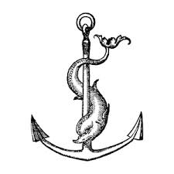
Festina lente

