Certificate in Corrections (12 hours)
The certificate in corrections is designed to accommodate both in-service officers interested in a specialized field, as well as undergraduate majors in any of the social sciences with a specific interest in the field of corrections. Specific career opportunities include corrections officer, corrections counselor, human services aide, residential juvenile counseling, street outreach counseling, juvenile corrections officer and the like. Upon completion of this certificate, the student will be able to demonstrate a thorough understanding of the functions of corrections within the broader criminal justice system.
CRJ 100 | Workshop in CJ (Corrections) | 1-3 Credit Hours
CRJ 265 | Juvenile Justice Systems | 3 Credit Hours
CRJ 341 | Introduction to Corrections | 3 Credit Hours
CRJ 345 | Community Corrections | 3 Credit Hours
CRJ 350 | Drugs & Society | 3 Credit Hours
CRJ 365 | Women & Crime | 3 Credit Hours
CRJ 374 | Mental Health & Criminal Justice System | 3 Credit Hours
CRJ 380 | Topics in Criminal Justice (Corrections) | 3 Credit Hours
CRJ 600 | Internship (with approval) | 3 Credit Hours
CRJ 670 | Independent Study (with approval) | 3 Credit Hours
CRJ 675 | Seminar in Criminal Justice | 3 Credit Hours
PSY 230 | Psychology of Human Motives | 3 Credit Hours
No grade lower than a “C” is acceptable for the classes taken to complete the certificate.
To obtain an official certificate for the Certificate in Corrections, fill out the Intent to Complete a Certificate in Corrections form on the right side of this page, and return to the Department of Criminal Justice. If you have met all the requirements, you should receive your certificate in the mail in approximately 3 – 4 weeks from the date of approval.
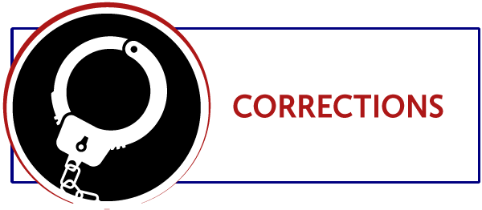
FORT HAYS STATE UNIVERSITY
DEPARTMENT OF CRIMINAL JUSTICE
Intent to Complete a Certificate in Corrections
Student ______________________________________________________ (Last Name) (First Name) (Middle Name)
Student ID# ___________________ Phone Number _______________
Major ________________________ E-mail _______________________
List the address the certificate should be mailed to:

(Street Address) (Apt. #)

(City) (State) (Zip Code)
Please indicate semester, year, and grade for each class completed:
Semester | Year | Grade
________ | _____ | _____ | CRJ 100 Workshop in CJ/CRJ 380 Topics in CJ
________ | _____ | _____ | CRJ 265 Juvenile Justice Systems
________ | _____ | _____ | CRJ 341 Introduction to Corrections
________ | _____ | _____ | CRJ 345 Community Corrections
________ | _____ | _____ | CRJ 350 Drugs & Society
________ | _____ | _____ | CRJ 365 Women & Crime
________ | _____ | _____ | CRJ 374 Mental Health & CJ System
________ | _____ | _____ | CRJ 380 Topics in CJ (Corrections)
________ | _____ | _____ | CRJ 600 Internship
________ | _____ | _____ | CRJ 670 Independent Study
________ | _____ | _____ | CRJ 675 Seminar in Criminal Justice
________ | _____ | _____ | PSY 230 Psychology of Human Motives
Student Signature ______________________________________________
For office use:
Certificate request approved on ________________________________________
Certificate printed on ________________________________________________
Certificate mailed to student on ________________________________________
131 Rarick Hall · 600 Park Street · Hays, KS 67601
(785)628-5668 · www.fhsu.edu/criminaljustice/

