Robot Throwdown Challenge 2021
Thank you to all who submitted entries for part one of this challenge! We received many creative ideas, and it was hard to pick our favorite, but here they are: these are the top 3 as picked by our team of judges.
You are all invited to compete in one or more of these challenges, even if you did not participate in part one of the competition. -G.G. Launchbaugh, 785-628-4538, fhsu.robotics@gmail.com

1: Break the Pyramid
created by Braelyn Stupka, Braxton Withington, Jason Dennis, and Ava Rodgers, of Colby Middle School
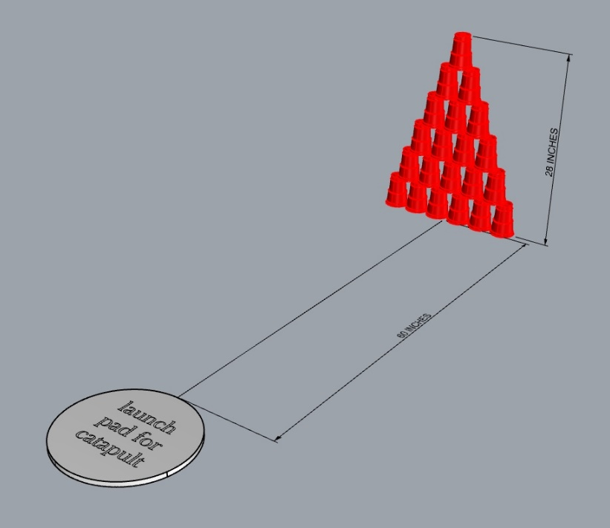

For this challenge you will build a catapult to throw a ping pong ball at a pyramid of (21) 16oz red plastic drinking cups (solo brand or similar) , attempting to knock them all over.
Cups shall be arranged as shown in drawing, with six on bottom row, 5 on next row, then 4, etc. Catapult will be located 60 inches away from pyramid.
Teams will have two attempts to throw a ping pong ball at the pyramid of cups, attempting to knock over as many as possible. If first attempt does not knock over all cups the second attempt will be taken with cups “as is” attempting to knock over the rest (as in bowling) if a cup is moved but not knocked over it is not counted.
Team receives 1 point for each cup knocked over, up to a maximum of 21 points.
The team with the most points wins.

Catapult should be built with standard Lego Mindstorms/ NXT/ EV3 kits, any sensors and motors may be used. String and or rubber bands are also allowed to be used to power the catapult.
Catapult must be programed so that button on control box is pressed, there is a 5 second count down, then catapult is triggered by the control box and ping pong ball is launched. Catapult may be reset manually by team members.

To compete in the challenge, team must submit an unedited video showing all attempts (up to 2) made during the allowed 10-minute period.
Camera should be positioned on a tripod so that it can keep the catapult and pyramid of cups in its field of view at all times.
A clock should also be placed within the field of view of the camera so times can be confirmed.
2: Beetlejuice Maze Challenge
Created by Eric Schroeder, Ryker Schmidtberger, and Jace Harper, Colby Middle School
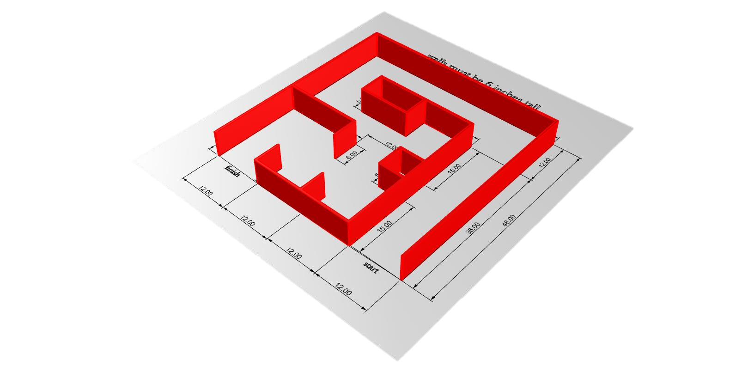
Objective: – navigate your robot through the maze from start to finish in the fastest time.

Rules: each team has 10 minutes to complete up to 5 attempts at navigating the maze.
Team will be scored on the fastest complete navigation during that 10 minutes.
Please time your runs and include the times with submission. Judges will time video to confirm.
Teams will place their robot at the starting line, press button on robot to activate it, and have no further inputs until the run is over, either by completing the maze, or failing and being reset to the starting line.
Robots must navigate through the maze on the floor, may not climb over or knock down walls
Teams will use standard Lego Mindstorms/ NXT/ EV3 kits to build their robots; any sensors and motors may be used.

First place will be awarded to the fastest navigation, second place second fastest, etc.

The maze will be built out of cardboard or wood, walls are to be 6 inches tall and no more than half an inch thick.
Maze walls must be securely fastened to base so that a robot bumping into a wall will not move the wall out of place.
Diagram below shows the pattern the maze walls need to be laid out in, dimensions are to centers of walls. maze is 48 inches by 48 inches.

To compete in the challenge, team must submit an unedited video showing all attempts made during the allowed 10-minute period.
Camera should be positioned high on a tripod so that it can look down and keep the entire maze in the field of view at all times.
A clock should also be placed outside the maze, but within the field of view of the camera so times can be confirmed.
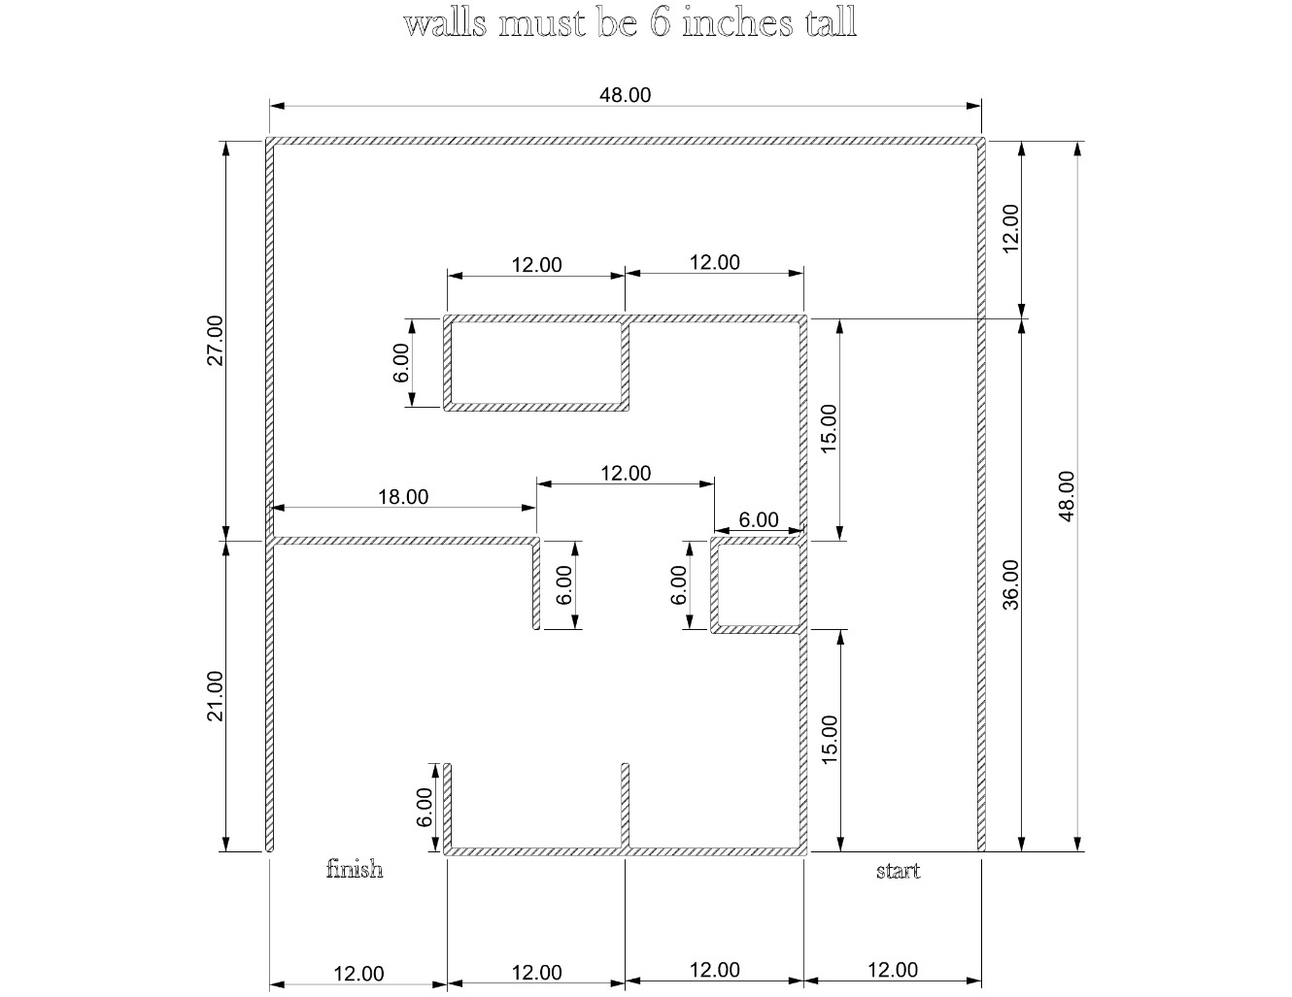

3: Self-timing Drag Race
Created by Oscar Flores, Gavin Green, Trenton Brown, and Jayden Jerome of Hays Middle School
Objective create the fastest drag-racing robot that times itself.

Robot will be placed behind green starting line, start button will be pressed by team member, the robot will give a 5 second countdown then race as fast as it can to cross the red finish line. Robot will be programmed to display correct elapsed time of run on screen.
Course will be marked with a 24-inch-long strip of green duct tape for the start line and 7 feet away from the start line, a 48-inch-long strip of red duct tape to mark the finish line. Robot is placed behind green line at start, run is complete when color sensor crosses red finish line.
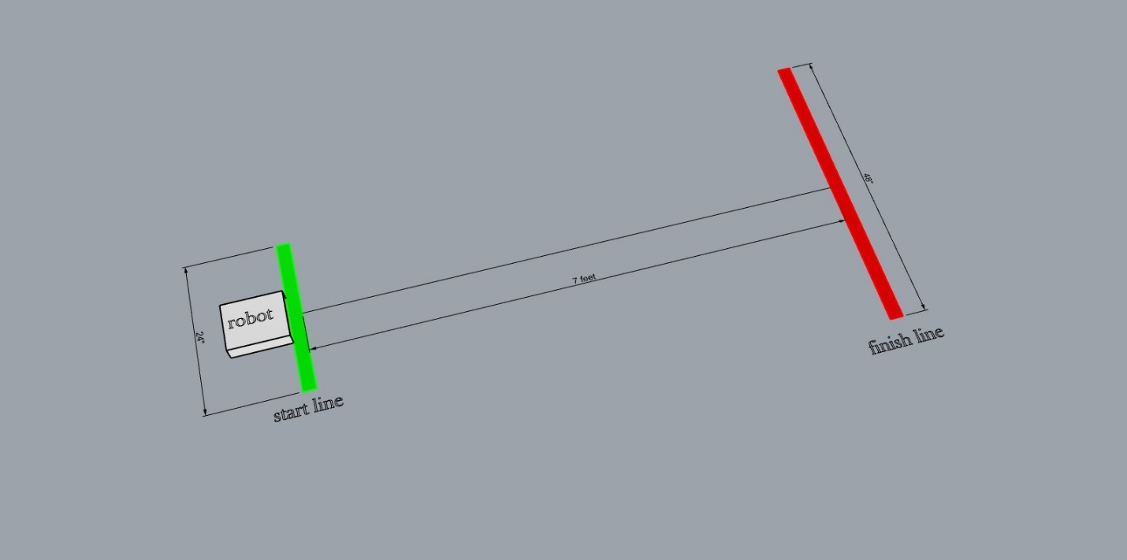

Teams will use standard Lego Mindstorms/ NXT/ EV3 kits to build their robots. color sensor and 2 motors may be used. Gear reductions on motors allowed. Robot must fit within 12-inch cube.

Teams will have 10 minutes to complete up to 3 runs of their dragster on the track.
Winner is the team with the fastest time. Run is disqualified if other requirements are not met ( 5 second count down, race time displayed correctly on robot’s screen)
To compete in the challenge, team must submit an unedited video showing all attempts (up to 3) made during the allowed 10-minute period.
Camera should be positioned so that it can keep the entire dragstrip in view during run, after each run, robot should be held in front of camera to confirm elapsed time display
A clock should also be placed within the field of view of the camera so times can be confirmed.

